# Overview

The purpose of this lab is to become familiar with importing and exporting data, killing a session that is deadlocked and using the Oracle dictionary.

## Contents

* + Part 1 - Use SQL Developer, the exp/imp utility and SQL Loader for data loading
  + Part 2 – Use SQL Developer for DBA Activities
  + Part 3 – Use Oracle Data Dictionary

## Due Date:

The lab is due no later than Friday Nov 10th. You must **hand in** PDFs of your work to the dropbox on D2L.

Scoring:   
Lab is worth **20** marks.

# Part 1 – Data Loading

The following lab is to be completed using SQL Developer, SQL Loader and the XE edition of Oracle. In part one you will be using various methods to unload and load data into an Oracle table(s).

1. Login into SQL Developer as **SYS** and create a new user ***Lab07*** with a password of ***Lab07*** and give them the DBA role.

2. Login to SQL Developer as user ***Lab07*** and run the ***Lotto649.sql*** script from the Lab07 D2L folder. This will create a table to hold all of the Lotto 6/49 draw results.

3. The data to be loaded is contained in ***Lotto649 Data.csv*** file in the Lab07 D2L folder. Load that data into the Lotto649 table using SQL Developer. SQL Developer contains an import wizard that you can step through to load the data into the table. On step 1, make sure you select the Windows <CR><LF> as the Line Terminator. On step 4, make sure you import the date in the proper format. On step 5, expand the import summary fields and take a screen shot. *(1 Mark)*

**Hand In**

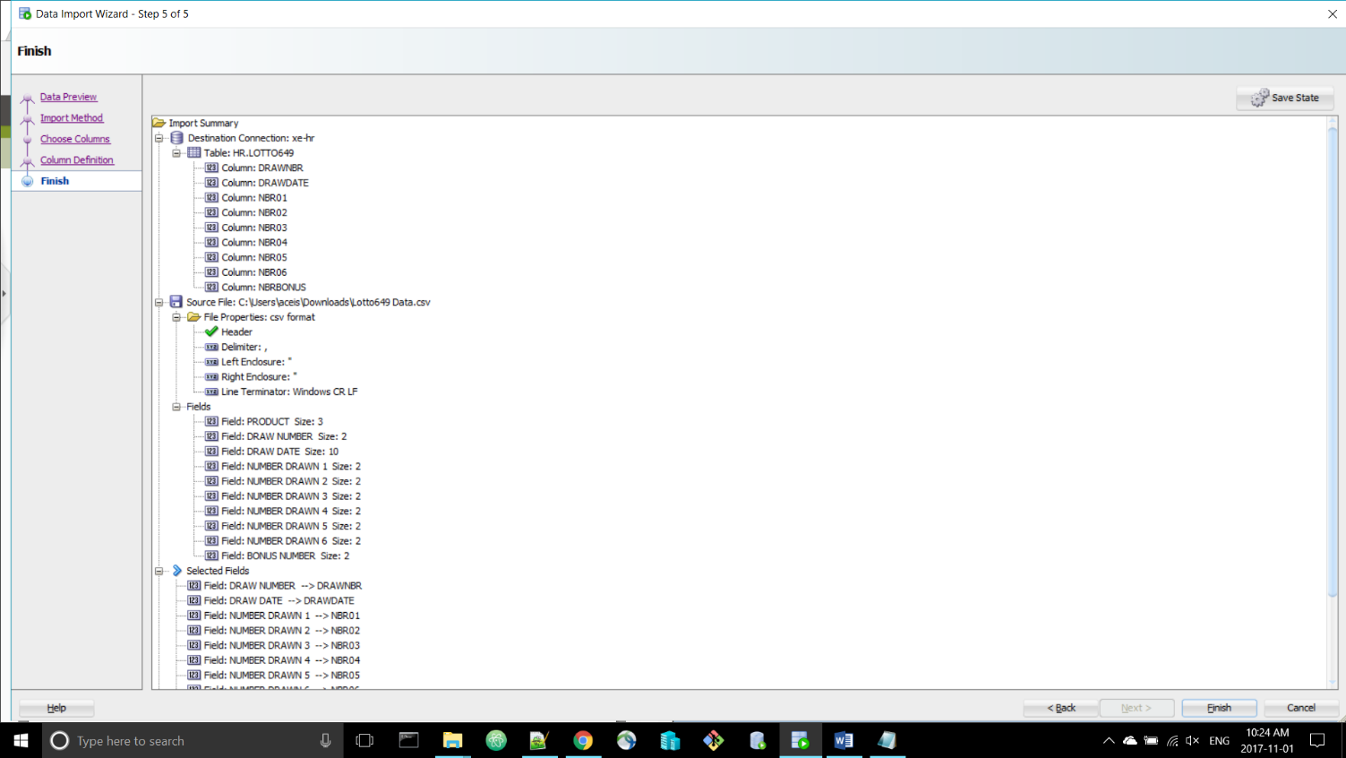

**Hand In**

4. After finishing the load, take a screen shoot of the first page displayed for the Data tab of the Lotto649 table. *(1 Mark)*

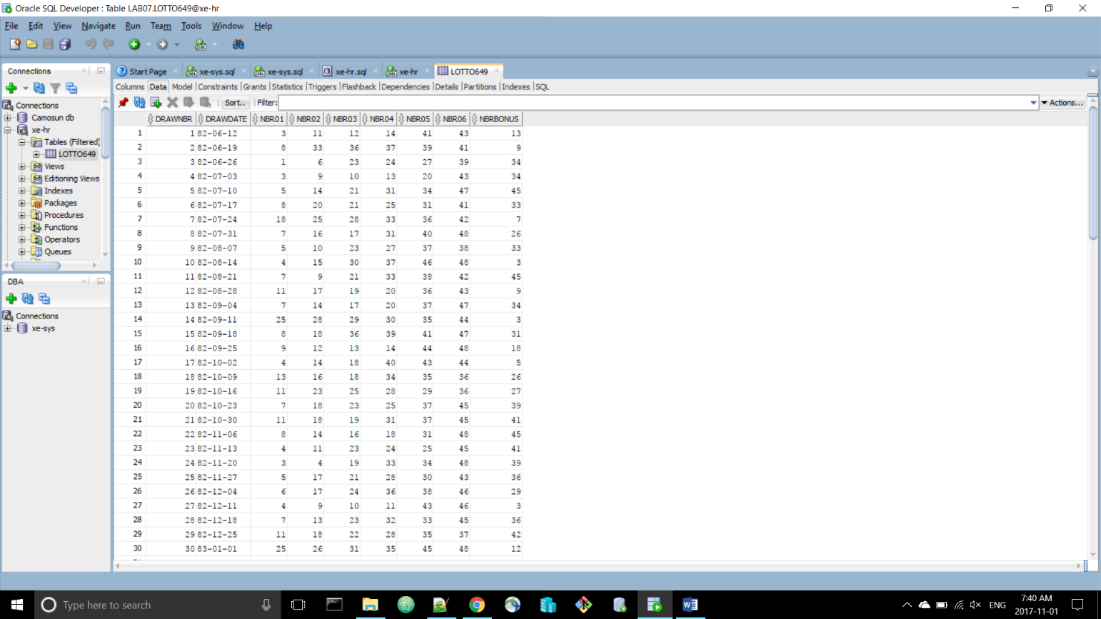

5. Create a new folder called **Lotto649 Export** **Loader Format** and now do an export of the lotto649 table using the **loader** format into that folder. Change the *Line Terminator* to “Windows <CR><LF>” and the *Save As* to Separate Files.

**Hand In**

6. Take a screen shot of the contents of the .ctl and .ldr files (first 20 lines only). *(1 Mark)*

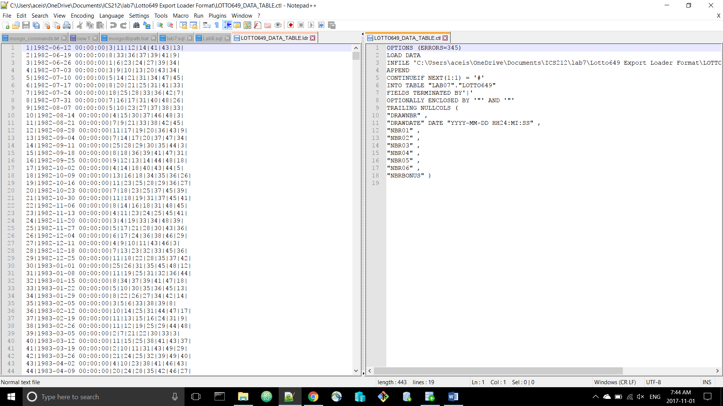

7. Create a new folder called **Lotto649 Export** **Insert Format** and do an export of the lotto649 table using the **insert** format.

**Hand In**

8. Take a screen shot of the contents of the export.sql file (first 20 lines only). *(1 Mark)*

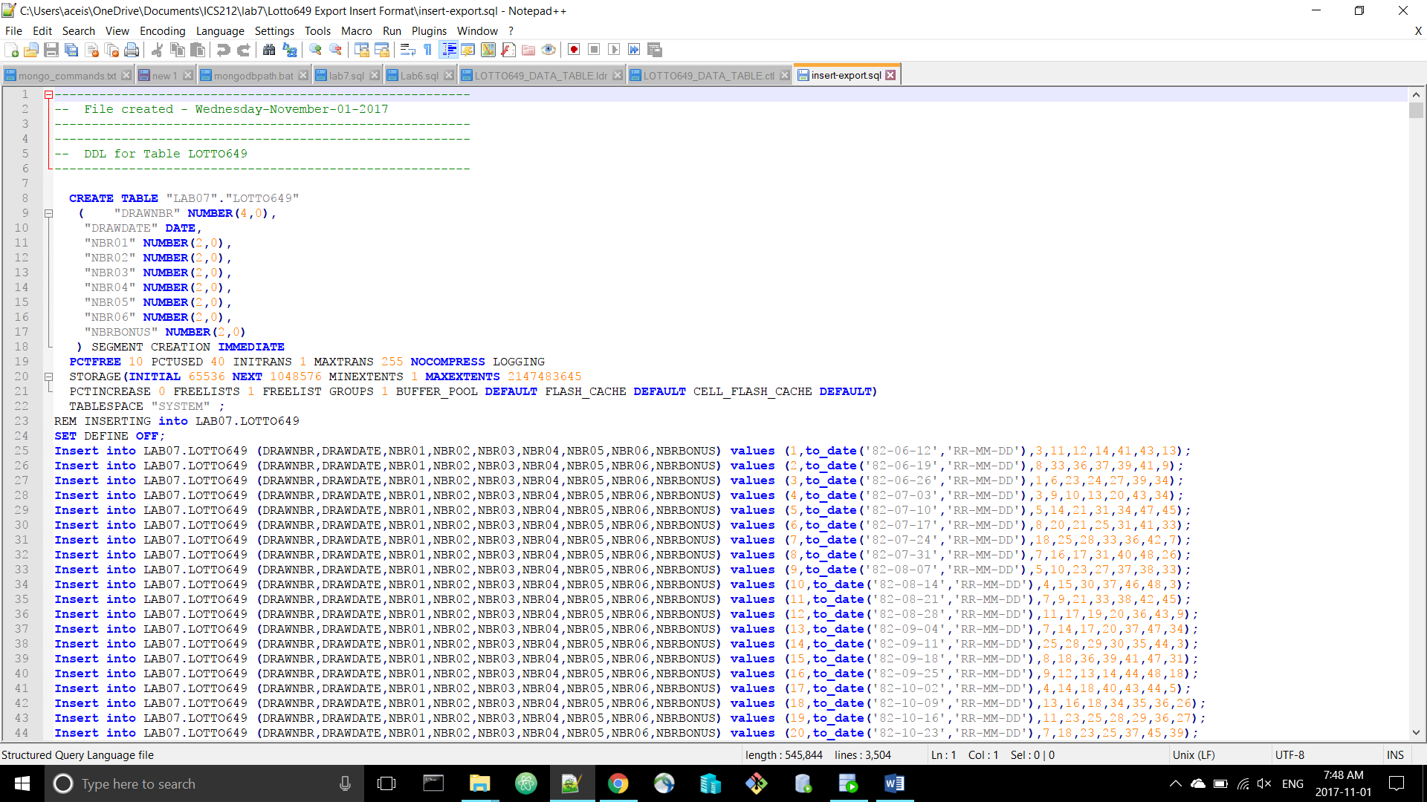

9. Drop the lotto69 table.

10. In SQL Developer, run the file that was created in step 7 and take a screen shoot of the results. *(1 Mark)*

**Hand In**

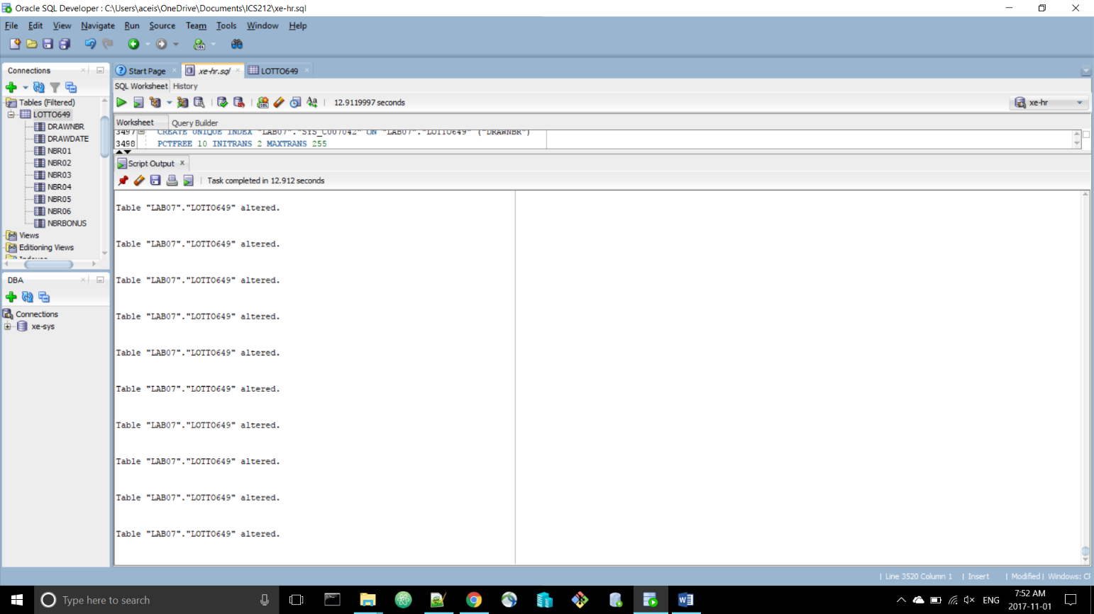

11. From the command line, use the **exp** utility to export the entire **HR** schema into a file called **hr.dmp.** Take a screen shoot of the command you executed and the results. *(2 Marks)*

**Hand In**

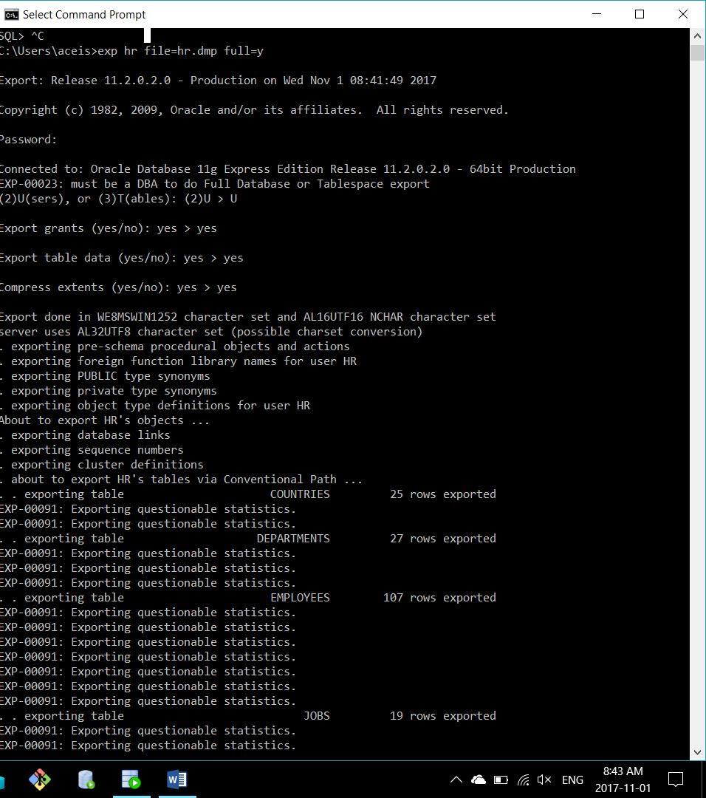

12. Login in to SQL Developer as the ***HR*** user and then run the script in ***HR Drop.SQL.***

13. From the command line, use the **IMP** utility to import the entire **HR** schema using the file created in step 11. Take a screen shoot of the command you executed and the results. *(2 Marks)*

**Hand In**

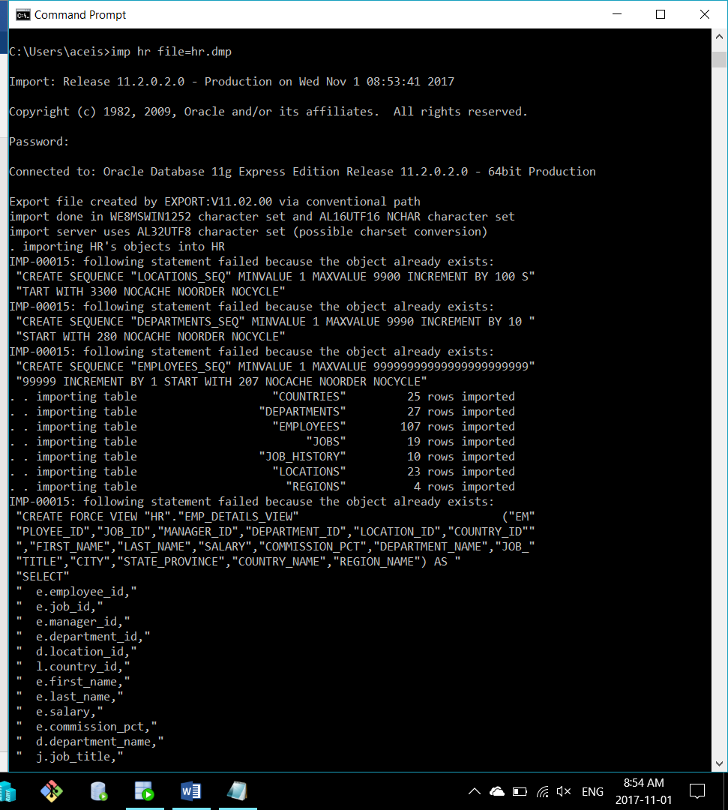

14. Use the files created in step 5 and sqlldr to load the lotto649 data into your student account on babbage*.* Take a screen shoot of the sqlldr command and the output from the sqlldr command. *(3 Marks)*

**Hand In**

*Hint: Create the Lotto649 table on babbage first. You can edit and rename the ctl and ldr files if you want to. 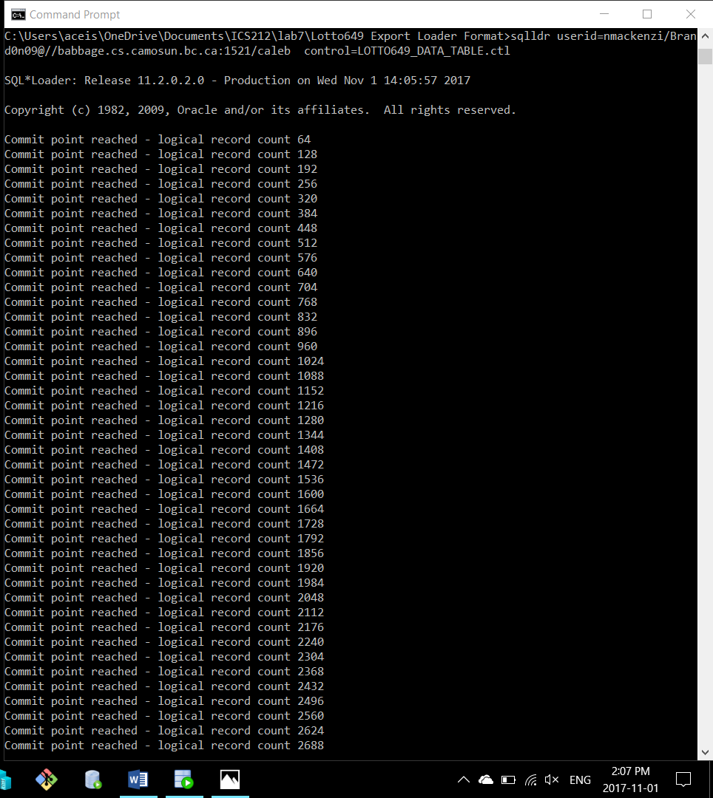*

# Part II DBA Activities

In part two you will be using SQL*Plus to create a deadlock situation and then SQL Developer to kill the session that is deadlocked.

1. Login into SQL Developer as **SYS** and create two new user ***User1*** with a password of ***User1***  and ***User2*** with a password of ***User2,***  give them both the DBA role.

2. From the command line, start up an SQL*Plus session with ***User1***. Enter the following commands:

CREATE TABLE mydual AS SELECT * FROM DUAL;  
INSERT INTO mydual VALUES ('Y');  
INSERT INTO mydual VALUES ('Z');  
COMMIT;  
SELECT * FROM mydual;  
UPDATE mydual SET dummy = 'Q';

3. From a new command line, start up a second SQL*Plus session with ***User2***. Enter the following command:

UPDATE User1.mydual SET dummy = 'M';

**Demo**

4. The second session should now be blocked. Start SQL Developer with your **SYS** account (which has the DBA role). Look for a blocking session and take corrective action. *(3 Marks)*

# Part III – Oracle Data Dictionary

In part three you will be writing queries against the Oracle Data Dictionary. The following queries can all be written in SQL Developer while logged onto the **HR** user in either Oracle Express or on the babbage server.

*Hint:* <http://oracledba.ezpowell.com/oracle/dataDictViews.html>

**Demo**

1. Write a query to display all the objects in the HR schema sorted by the object type. *(1 Mark)*

**Demo**

2. Write a query to display all the tables and the table comments in the HR schema sorted by table name. *(1 Mark)*

**Demo**

3. Write a query to display the system privileges that HR has. *(1 mark)*

**Demo**

4. Write a query to display the roles that HR has. *(1 Mark)*

5. Write a query to display all the tables along with the tablespace and schema they are in that HR has access to. (1 Mark)

**Demo**